BUNBURY SENIOR HIGH SCHOOL

Mathematics Methods 1 | Unit 1

Investigation 1 – Graphs and transformations

## IN CLASS VALIDATION TEST

## NAME: _________________________________ DATE: ____________

**Time allowed for this task:** Up to 50 minutes, in-class, under test conditions

**Materials required:** Standard writing equipment

**Other materials allowed:** Drawing templates, page of notes with writing on one side

Calculators are **not** permitted

**Marks available: 50 marks**

**Task weighting: 6%**

**Question 1 (13 marks)**

1. Describe the transformation(s) required to change
2.  (1 mark)
3.  (1 mark)
4. . (2 marks)
5. Describe the transformation of each of these functions for the given changes to ().

|  |  |  |  |
| --- | --- | --- | --- |
|  | Functions | is doubled | is multiplied by -1 |
| (i) |  |  | (3 marks) |
| (ii) |  |  | (3 marks) |
| (iii) |  |  | (3 marks) |

**Question 2 (8 marks)**

1. The mid-point of a line segment joining the points (-2, 2) and (6, 18) is (2, 10). The linear rule for the line segment is  and the segment is translated so that the rule becomes. State the coordinates of the new mid-point. (2 marks)
2. The mid-point of a line segment with the general equation  is (-4, -5) as shown on the diagram below.

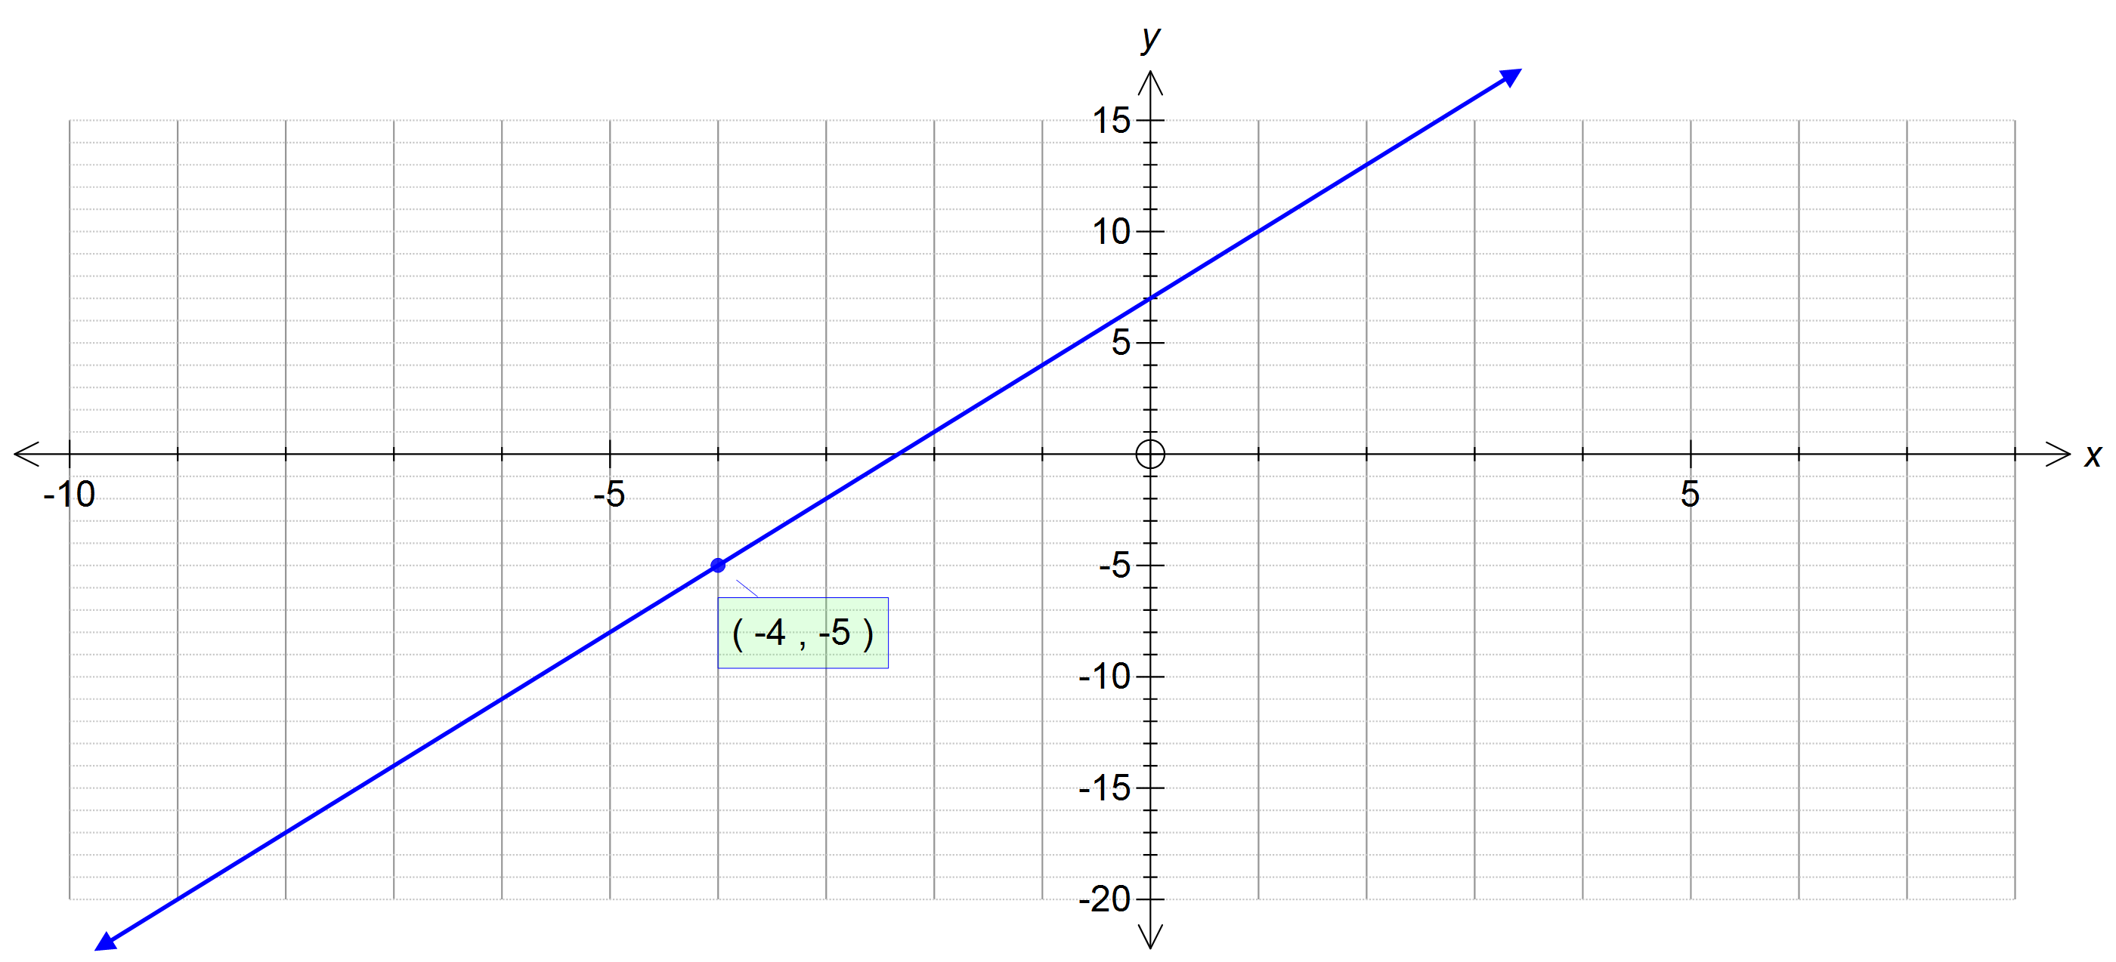

(i) Reflect the line over the -axis and draw the result. (1 mark)

(ii) State the equation of the transformed line. (1 mark)

(ii) State the mid-point of the transformed segment. (2 marks)

(c) A line segment with the general equation  was translated so that the new rule is ,  and the new mid-point is. What was the mid-point originally?

(2 marks)

**Question 3 (10 marks)**

You are provided with graphs of the function on each grid. Draw the resulting graphs for the transformations given.

(a) reflection over the -axis (2 marks) (b) translation 6 units down (2 marks)

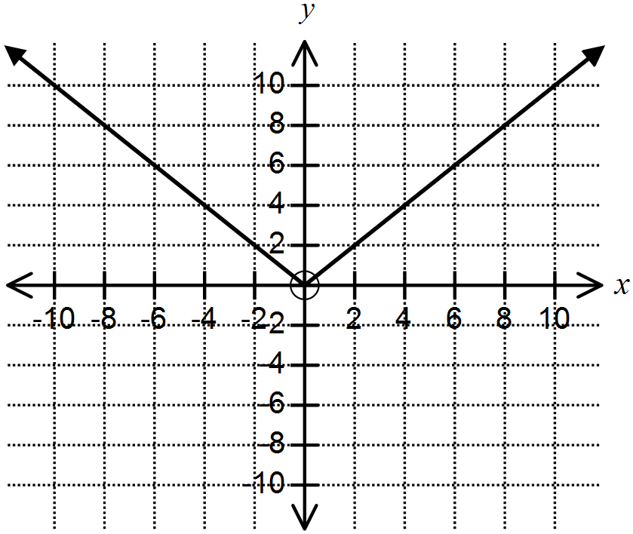

(c)  (1 mark) (d)  (2 marks)



(e)  (1 mark) (f)  (2 marks)



**Question** 4 **(6 marks)**

Draw graphs to represent the transformations described.

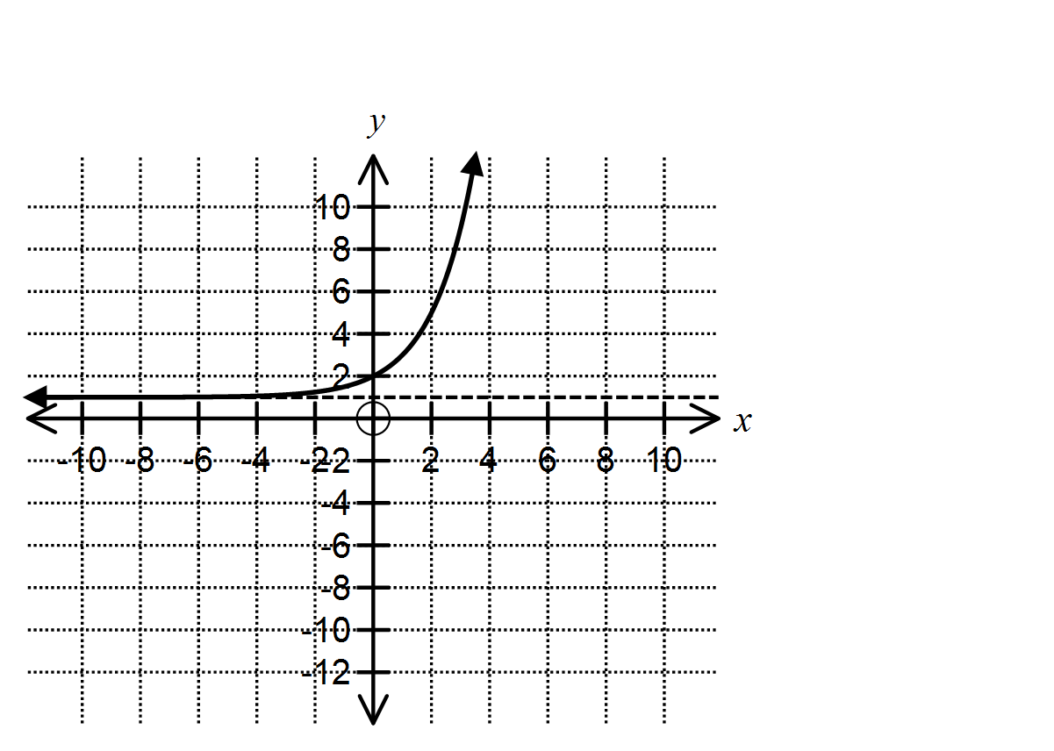

(a) vertical translation by 5 units down (1 mark) (b) reflection in the -axis (1 mark)

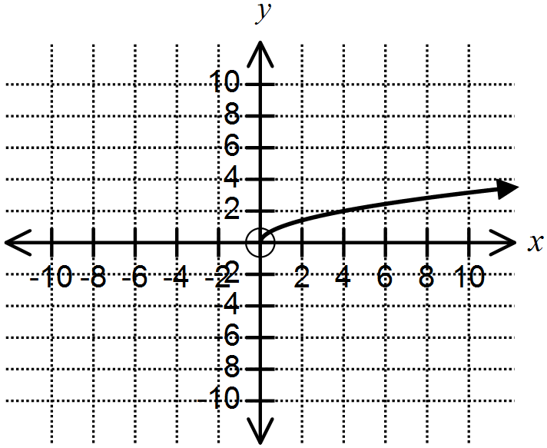

(c) translation left by 4 units followed by a reflection in the -axis (2 marks)

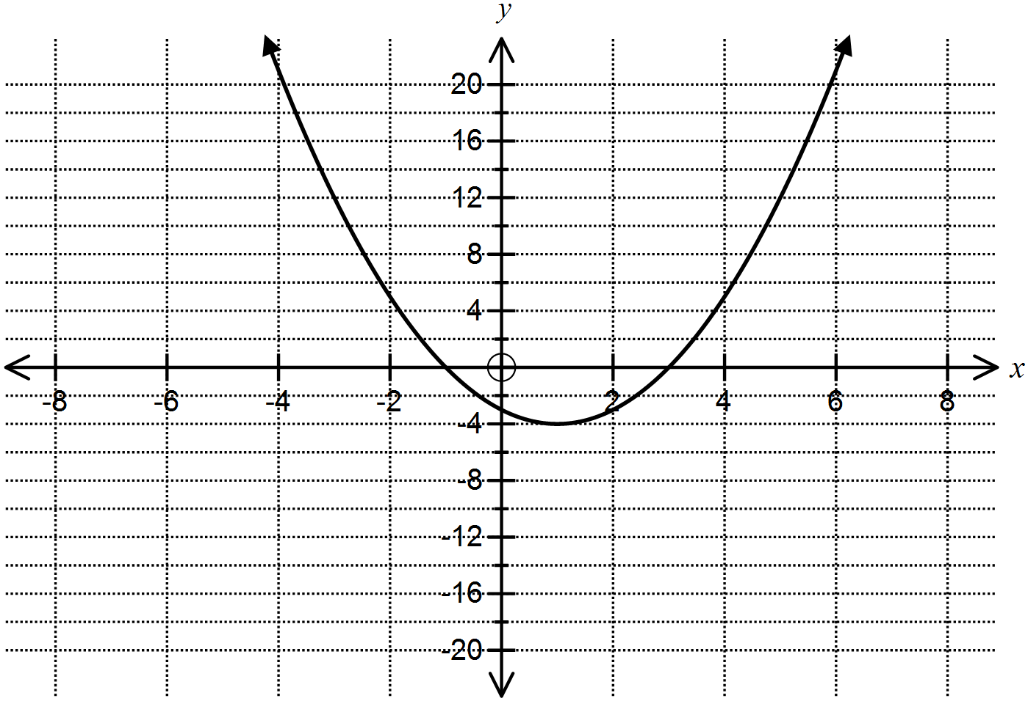

(d) the graph already drawn on each grid is  (2 marks)

(i)  (ii) 

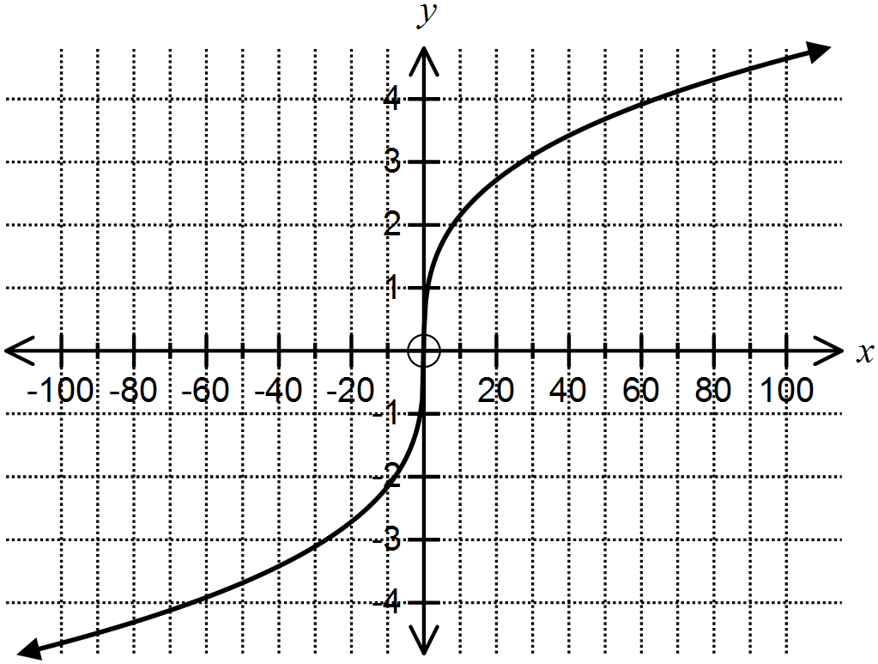

**Question 5**  **(5 marks)**

State the equations of the graphs formed by the transformations of the given functions.

(a) (1 mark) (b) (1 mark)

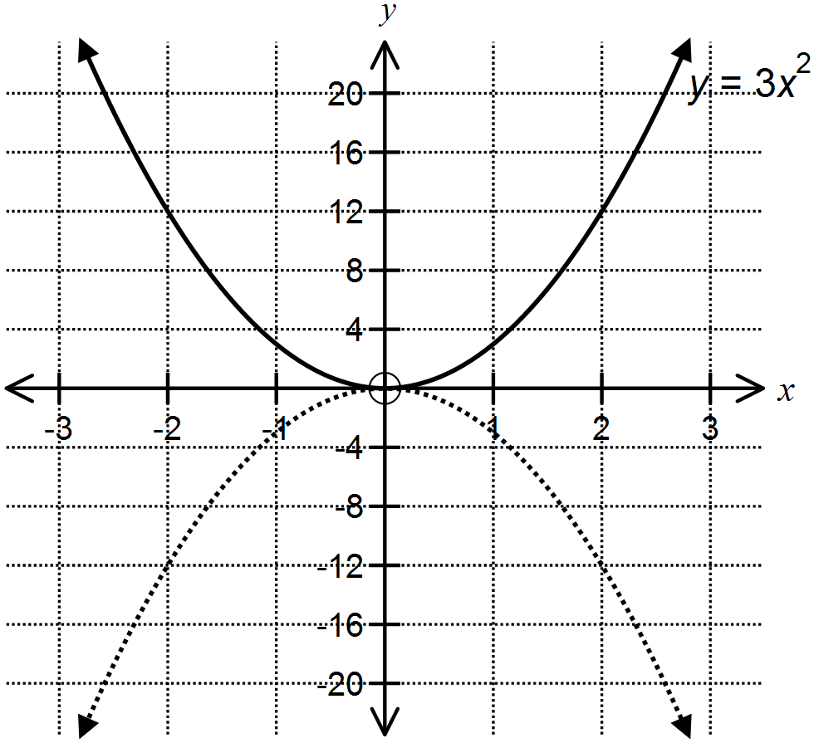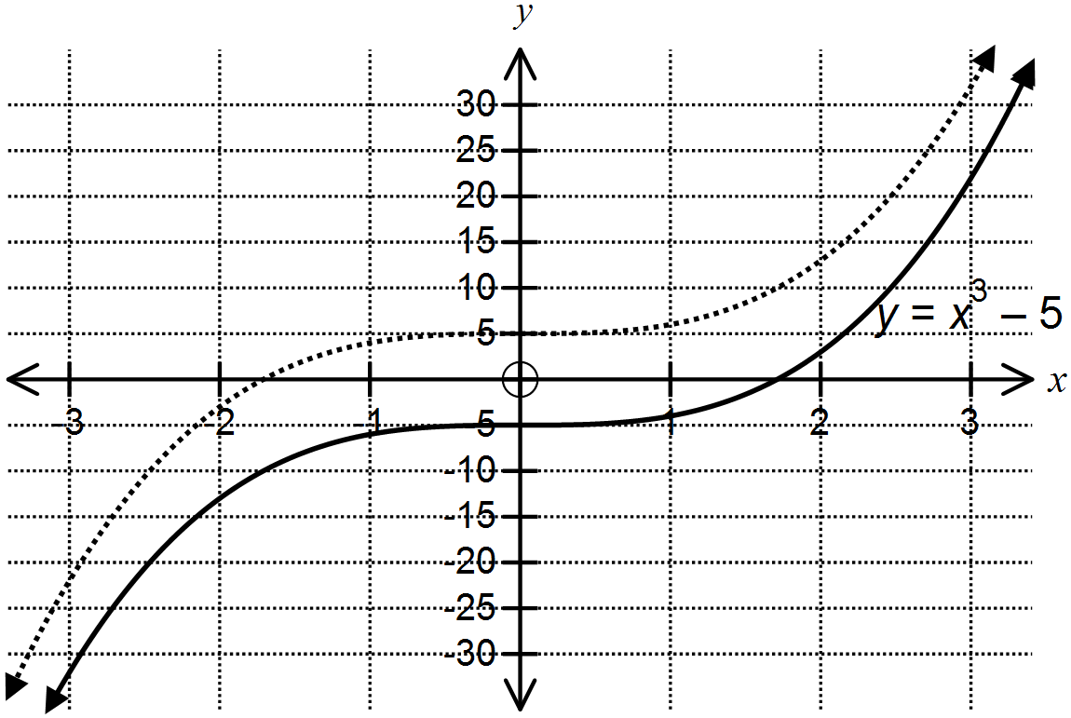

(c) (1 mark)

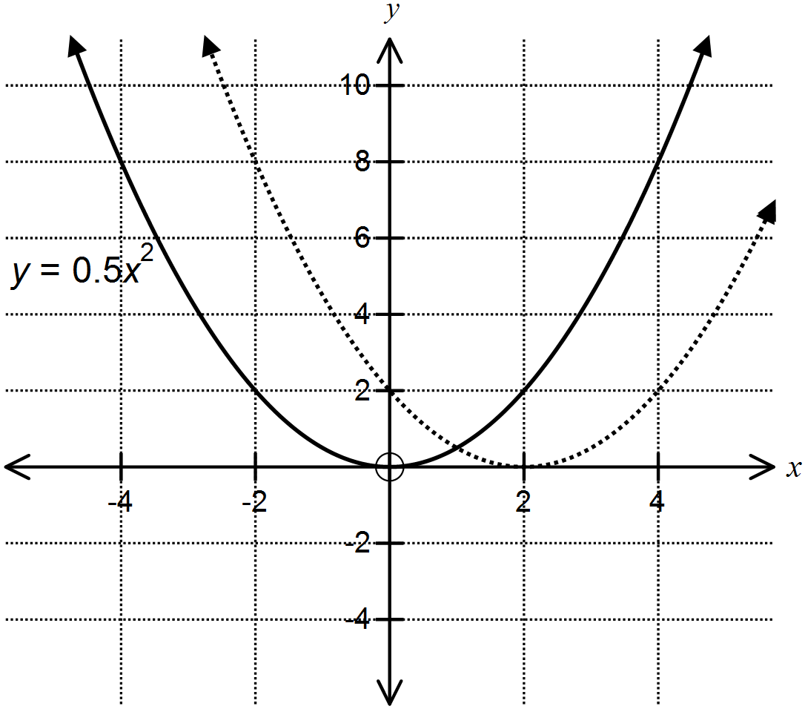

|  |  |  |
| --- | --- | --- |
| (a) | (b) | (c) |

(d) The graph of  is reflected in the -axis and then translated vertically down by   
5 units.

(2 marks)

**Question 6 (8 marks)**

Complete the tables provided by entering the missing data.

1. Identify the line of symmetry and the -intercept for the transformed function. (2 marks)

|  |  |  |
| --- | --- | --- |
|  | Original function | Transformed function |
| Line of symmetry |  |  |
| -intercept | (0, 0) |  |

1. Identify the turning point and the line of symmetry for the transformed function. (2 marks)

|  |  |  |
| --- | --- | --- |
|  | Original function | Transformed function |
| Turning point | (*a*, 12) |  |
| Line of symmetry |  |  |

(c) For any general point (*a, b*) on the original function, name the corresponding point on the transformed function. (2 marks)

|  |  |  |
| --- | --- | --- |
|  | Original function | Transformed function |
| Point | (*a, b*) |  |

(d) For any general point (*a, b*) on the transformed function, name the corresponding point on the original function. (2 marks)

|  |  |  |
| --- | --- | --- |
| Variables *p, m, k* and *w* are positive | Original function | Transformed function |
| Point |  | (*a, b*) |